# ITMD 463/563 Project 2

This is project 2.  Here is what you need to do:

1. Connect to your local SQL Server Express (which is installed with Visual Studio) – see the video lecture where I show how to do this.
2. Create the Northwinds database using the instnwnd.sql – see the video lecture where I show how to do this.
3. Create an ASP.NET Webform with a GridView and SqlDataSource that connects to the Customer OR Products OR Orders database (you pick). The output will look like something like this. You can look at “GridView ASPNET Page.wmv” for an example of creating the GridView (this is also recorded in the lecture as well).

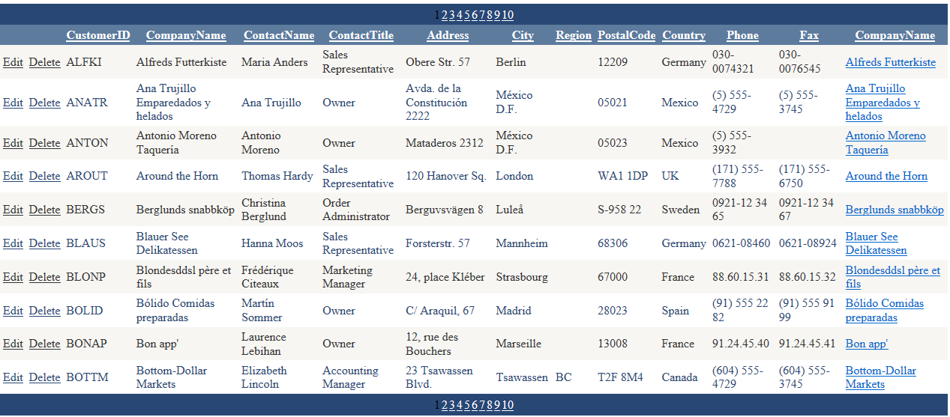

You can use the example below to create your project.

1. From the file menu pick File>New>Project﻿

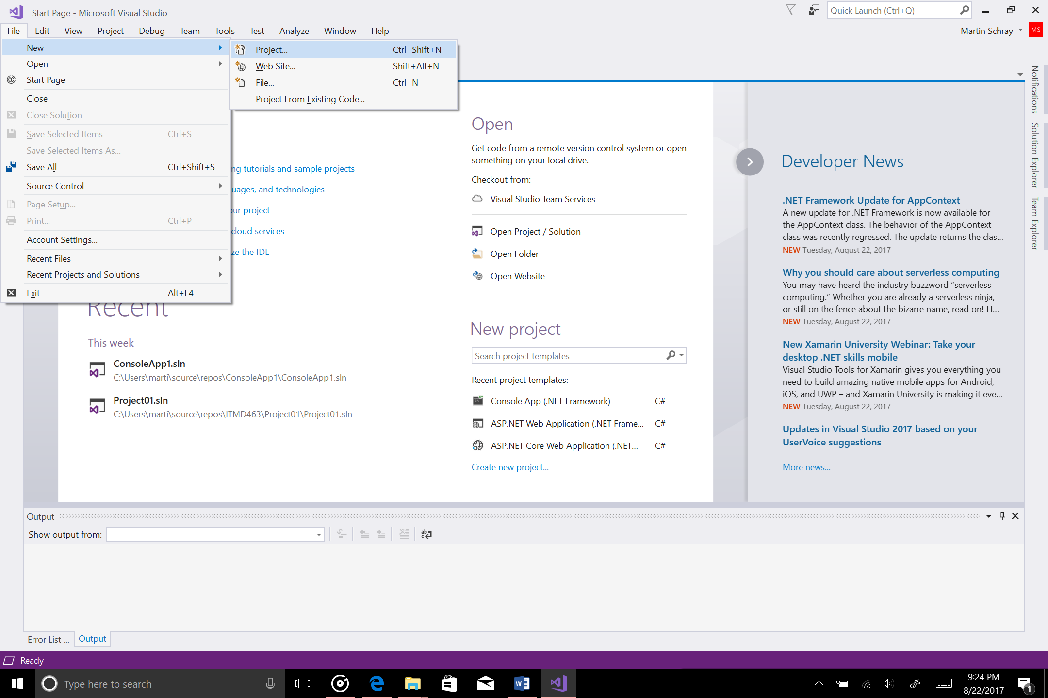

2. From the dialog that opens pick Web

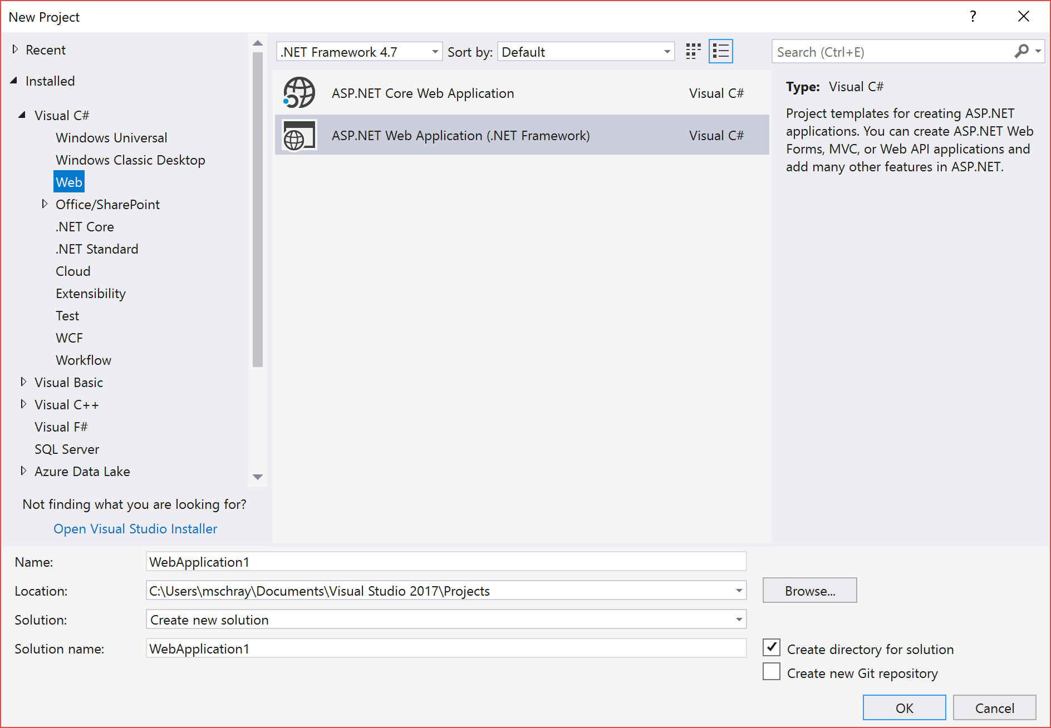

3. Pick the following project settings

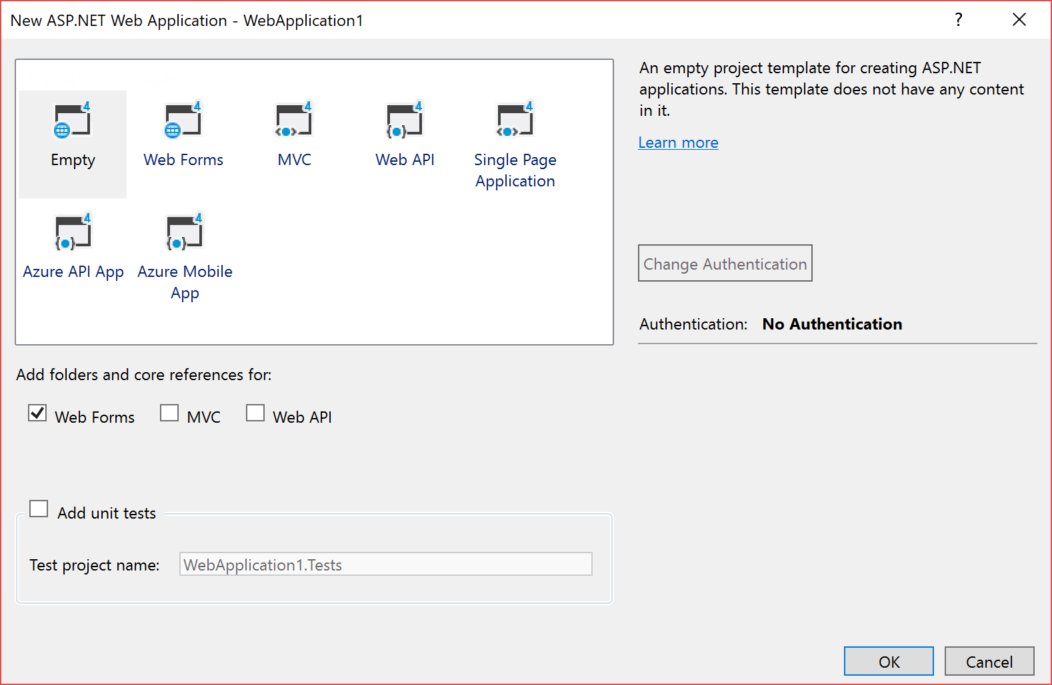

4. Pick Project>Add New Item and Web Form

